ECE 684: Natural Language Processing
Assignment 6 – Latent Dirichlet Allocation
Nruta Choudhari
Q. Show the inferred beta vectors and indicate how they map to the true topics above.
A. Beta values:
Inferred Beta values:
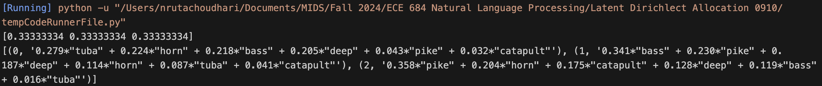

In the beta values:
Topic 1: [0.4 0.4 0.2 0.0 0.0 0.0]
Topic 2: [0.0 0.3 0.1 0.0 0.3 0.3]
Topic 3: [0.3 0.0 0.2 0.3 0.2 0.0]

From the inferred values:
Inferred Topic 0:
- “tuba” (0.279), “horn” (0.224) and “bass” (0.218) suggest a strong musical theme
- Other words like “deep” (0.205) may also relate to musical terms, indicating that this topic primarily focuses on music-related concepts
- This split is consistent with Topic 2

Inferred Topic 1:
- “bass” (0.341), “pike” (0.230) could suggest a theme related to fishing, as “bass” also refers to a type of fish.
- Words like “deep” (0.187) and “horn” (0.114) might also relate to sound or depth, adding complexity to the topic
- This split is consistent with Topic 1

Inferred Topic 2:
- “pike” (0.358), “horn” (0.204) and “catapult” (0.175) indicates a hunting theme.
- The split is consistent with Topic 3

